VISVESVARAYA TECHNOLOGICAL UNIVERSITY

“JnanaSangama”, Belgaum -590014, Karnataka.

LAB REPORT
On
ANALYSIS AND DESIGN OF ALGORITHMS (23CS4PCADA)

Submitted by
KOTHA NAGA JYOTHISH (1BF24CS147)

in partial fulfillment for the award of the degree of BACHELOR OF ENGINEERING
in
COMPUTER SCIENCE AND ENGINEERING


B.M.S. COLLEGE OF ENGINEERING
(Autonomous Institution under VTU) BENGALURU-560019
February to June 2026 CERTIFICATE

B. M. S. College of Engineering,
Bull Temple Road, Bangalore 560019
(Affiliated To Visvesvaraya Technological University, Belgaum) Department of Computer Science and Engineering


This is to certify that the Lab work entitled “ANALYSIS AND DESIGN OF ALGORITHMS” carried out by KOTHA NAGA JYOTHISH (1BF24CS147l), who is bonafide student of B. M. S. College of Engineering. It is in partial fulfillment for the award of Bachelor of Engineering in Computer Science and Engineering of the Visvesvaraya Technological University, Belgaum during the year 2025-26. The Lab report has been approved as it satisfies the academic requirements in respect of Analysis and Design of Algorithms Lab - (23CS4PCADA) work prescribed for the said degree.

Dr.Priyanka
Chandrasheker
Hiremath Dr. Kavitha Sooda
Assistant Professor Professor and Head
Department of CSE Department of CSE
BMSCE, Bengaluru BMSCE, Bengaluru

Index Sheet

Sl. No. | Experiment Title | Page No.
1 | Write program to obtain the Topological ordering of vertices in a given digraph. | 4-6
2 | Implement Johnson Trotter algorithm to generate permutations. | 7-9
3 | Sort a given set of N integer elements using Merge Sort technique and compute its time taken. Run the program for different values of N and record the time taken to sort. | 10-12
4 | Sort a given set of N integer elements using Quick Sort technique and compute its time taken. | 13-15
5 | Sort a given set of N integer elements using Heap Sort technique and compute its time taken. | 16-18
6 | Implement 0/1 Knapsack problem using dynamic programming. | 19-20
7 | Implement All Pair Shortest paths problem using Floyd’s algorithm. | 21-22
8 | - Find Minimum Cost Spanning Tree of a given undirected graph using Prim’s a algorithm.  - Find Minimum Cost Spanning Tree of a given undirected graph using Kruskal’s algorithm. | 23-24  25-26
9 | Implement Fractional Knapsack using Greedy technique. | 27-28
10 | From a given vertex in a weighted connected graph, find shortest paths to other vertices using Dijkstra’s algorithm. | 29-30
11 | Implement “N-Queens Problem” using Backtracking. | 31-32

Course outcomes:
CO1 | Analyze time complexity of algorithms using asymptotic notations.
CO2 | Apply various algorithm design techniques for the given problem.
CO3 | Evaluate the appropriate algorithm/design technique for solving a given problem.
CO4 | Conduct practical experiments by applying appropriate algorithm design technique to solve problems.

Lab program 1:
Write program to obtain the Topological ordering of vertices in a given digraph.
#include <stdio.h> #include <stdlib.h> #include <time.h>
int a[1000][1000], visited[1000], stack[1000]; int top=-1,n;
void topo(int v)
{
visited[v]=1;

for(int i=0;i<n;i++) if(a[v][i] && !visited[i])
topo(i);
stack[++top]=v;
}
void reset()
{
top=-1;
for(int i=0;i<n;i++) visited[i]=0;
}
void generateGraph(int n)
{
for(int i=0;i<n;i++) for(int j=0;j<n;j++)
if(i<j)
a[i][j]=rand()%2; else
a[i][j]=0;
}
int main()
{
clock_t start,end; double time_taken;
printf("Enter number of vertices: "); scanf("%d",&n);
printf("Enter adjacency matrix:\n"); for(int i=0;i<n;i++)
for(int j=0;j<n;j++) scanf("%d",&a[i][j]);
reset();
for(int i=0;i<n;i++)
if(!visited[i]) topo(i);
printf("\nTopological Ordering:\n"); while(top!=-1)
printf("%d ",stack[top--]); printf("\n\nVertices\tTime(ms)\n"); for(n=100;n<=500;n+=100)
{
reset(); generateGraph(n); start=clock(); for(int i=0;i<n;i++)
if(!visited[i]) topo(i);
end=clock();
time_taken=((double)(end-start))*1000/CLOCKS_PER_SEC; printf("%d\t\t%.2f\n",n,time_taken);
}
return 0;
}

OUTPUT:
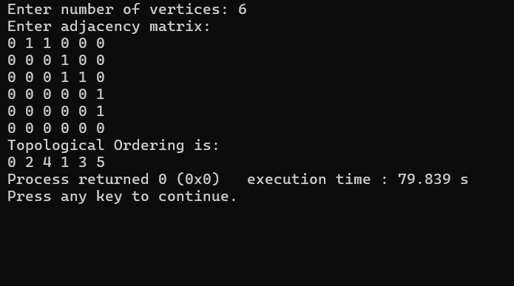

GRAPH:
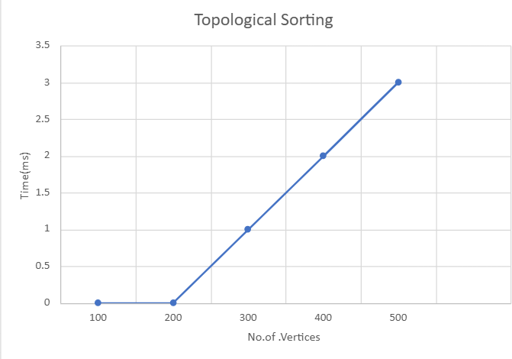
LAB PROGRAM 2:

#include <stdio.h>

int getMobile(int a[], int dir[], int n)
{
int mobile = 0, mobile_prev = 0;
for(int i = 0; i < n; i++)
{
if(dir[a[i]-1] == 0 && i != 0)
{
if(a[i] > a[i-1] && a[i] > mobile_prev)
{
mobile = a[i]; mobile_prev = mobile;
}
}

if(dir[a[i]-1] == 1 && i != n-1)
{
if(a[i] > a[i+1] && a[i] > mobile_prev)
{
mobile = a[i]; mobile_prev = mobile;
}
}
} return mobile;
}

int searchPos(int a[], int n, int mobile)
{
for(int i = 0; i < n; i++) if(a[i] == mobile)
return i;
}
void printPermutation(int a[], int n)
{
for(int i = 0; i < n; i++) printf("%d ", a[i]);
printf("\n");
}

void johnsonTrotter(int n)
{
int a[n], dir[n];

for(int i = 0; i < n; i++)
{
a[i] = i + 1;
dir[i] = 0;
}
printPermutation(a, n); for(int i = 1; i < n; i++)
{
for(int j = 0; j < i * (i + 1) / 2; j++);
}
int fact = 1;
for(int i = 1; i <= n; i++) fact *= i;

for(int i = 1; i < fact; i++)
{
int mobile = getMobile(a, dir, n); int pos = searchPos(a, n, mobile);

if(dir[mobile-1] == 0)
{
int temp = a[pos]; a[pos] = a[pos-1]; a[pos-1] = temp; pos--;
}
else
{
int temp = a[pos]; a[pos] = a[pos+1]; a[pos+1] = temp; pos++;
}
for(int j = 0; j < n; j++) if(a[j] > mobile)
dir[a[j]-1] = 1 - dir[a[j]-1];

printPermutation(a, n);
}
}

int main()
{
int n;
printf("Enter number of elements: "); scanf("%d", &n);
johnsonTrotter(n);
return 0;
}

OUTPUT :
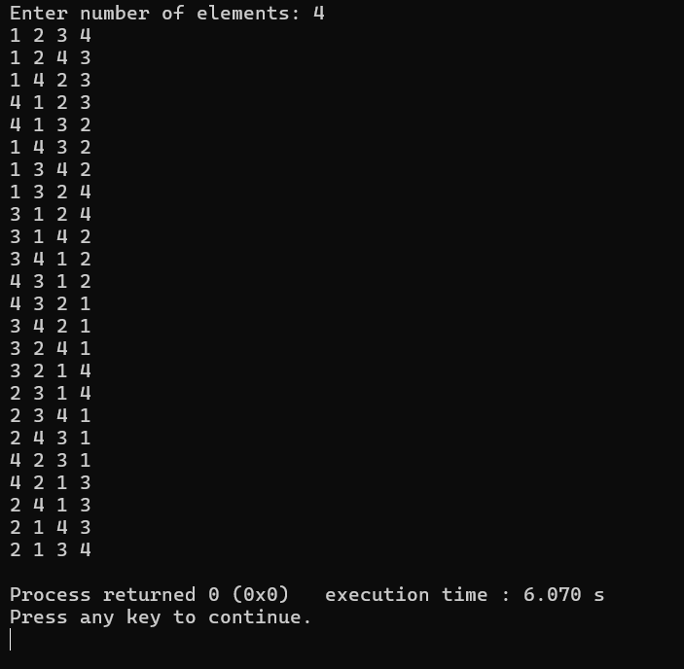
LAB PROGRAM 3:

#include<stdio.h> #include<stdlib.h> #include<time.h>

void merge(int a[],int low,int mid,int high)
{
int i=low,j=mid+1,k=0,b[100000];
while(i<=mid && j<=high)
{
if(a[i]<a[j])
b[k++]=a[i++];
else
b[k++]=a[j++];
}

while(i<=mid) b[k++]=a[i++];

while(j<=high) b[k++]=a[j++];
for(i=low,k=0;i<=high;i++,k++) a[i]=b[k];
}

void mergesort(int a[],int low,int high)
{
if(low<high)
{
int mid=(low+high)/2; mergesort(a,low,mid); mergesort(a,mid+1,high); merge(a,low,mid,high);
}
}

int main()
{
int a[100000],n;
int values[5]={100,500,1000,2000,3000};
clock_t start,end; double time_taken;

printf("Enter number of elements: "); scanf("%d",&n);

printf("Enter elements:\n");

for(int i=0;i<n;i++) scanf("%d",&a[i]);
mergesort(a,0,n-1); printf("\nSorted elements:\n"); for(int i=0;i<n;i++)
printf("%d ",a[i]); printf("\n\nN\tTime(ms)\n");
for(int i=0;i<5;i++)
{
n=values[i];

for(int j=0;j<n;j++) a[j]=rand()%10000;

start=clock(); mergesort(a,0,n-1); end=clock();
time_taken=((double)(end-start))*1000/CLOCKS_PER_SEC;

printf("%d\t%.2f\n",n,time_taken);
}

return 0;
}
OUTPUT:
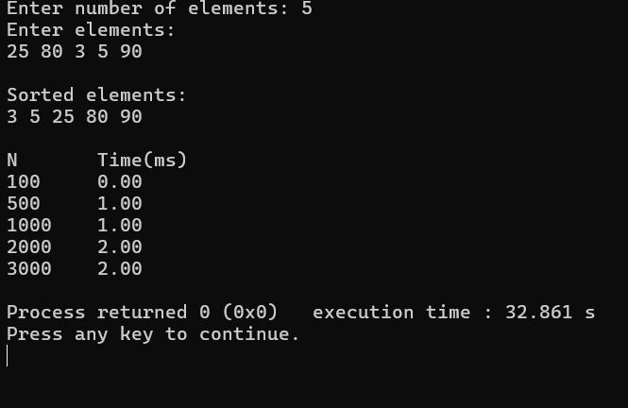

GRAPH :
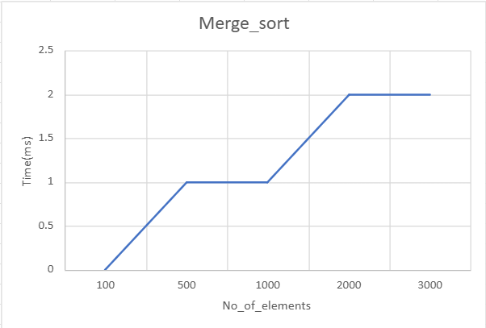

LAB PROGRAM 4:

#include<stdio.h> #include<stdlib.h> #include<time.h>

int partition(int a[],int low,int high)
{
int pivot=a[low],i=low+1,j=high,temp;

while(1)
{
while(i<=high && a[i]<=pivot) i++; while(a[j]>pivot) j--;

if(i<j)
{
temp=a[i]; a[i]=a[j]; a[j]=temp;
}
else
break;
}

temp=a[low]; a[low]=a[j]; a[j]=temp;

return j;
}
void quicksort(int a[],int low,int high)
{
if(low<high)
{
int p=partition(a,low,high); quicksort(a,low,p-1); quicksort(a,p+1,high);
}
}
int main()
{
int a[100000],b[100000],n;
int values[5]={100,500,1000,2000,3000};
clock_t start,end; double time_taken;

printf("Enter number of elements: "); scanf("%d",&n);
printf("Enter elements:\n"); for(int i=0;i<n;i++)
scanf("%d",&a[i]);
quicksort(a,0,n-1); printf("\nSorted elements:\n"); for(int i=0;i<n;i++)
printf("%d ",a[i]);
printf("\n\nN\tTime(ms)\n"); for(int i=0;i<5;i++)
{
n=values[i];

for(int j=0;j<n;j++) a[j]=rand()%10000;
start=clock();
for(int k=0;k<500;k++)
{
for(int j=0;j<n;j++) b[j]=a[j];
quicksort(b,0,n-1);
}

end=clock();

time_taken=((double)(end-start))*1000/CLOCKS_PER_SEC;
printf("%d\t%.2f\n",n,time_taken);
}
return 0;
}

OUTPUT :
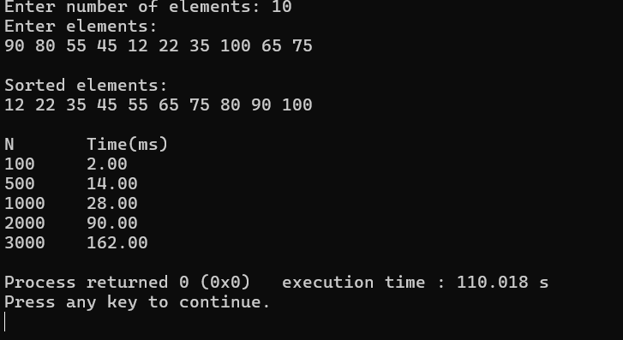

GRAPH :
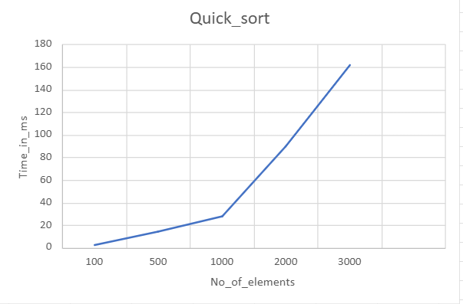

LAB PROGRAM 5:
#include<stdio.h> #include<stdlib.h> #include<time.h>

void heapify(int a[],int n,int i)
{
int largest=i,l=2*i+1,r=2*i+2,temp;

if(l<n && a[l]>a[largest]) largest=l;
if(r<n && a[r]>a[largest]) largest=r;
if(largest!=i)
{
temp=a[i]; a[i]=a[largest]; a[largest]=temp;
heapify(a,n,largest);
}
}

void heapsort(int a[],int n)
{
for(int i=n/2-1;i>=0;i--) heapify(a,n,i);
for(int i=n-1;i>0;i--)
{
int temp=a[0]; a[0]=a[i]; a[i]=temp;

heapify(a,i,0);
}
}

int main()
{
int a[100000],b[100000],n;
int values[5]={100,500,1000,2000,3000};
clock_t start,end; double time_taken;
printf("Enter number of elements: "); scanf("%d",&n);
printf("Enter elements:\n"); for(int i=0;i<n;i++)

scanf("%d",&a[i]); heapsort(a,n);
printf("\nSorted elements:\n");

for(int i=0;i<n;i++) printf("%d ",a[i]);
printf("\n\nN\tTime(ms)\n"); for(int i=0;i<5;i++)
{
n=values[i];

for(int j=0;j<n;j++) a[j]=rand()%10000;
start=clock();

for(int k=0;k<500;k++)
{
for(int j=0;j<n;j++) b[j]=a[j];
heapsort(b,n);
}

end=clock();

time_taken=((double)(end-start))*1000/CLOCKS_PER_SEC;

printf("%d\t%.2f\n",n,time_taken);
}

return 0;
}
OUTPUT :
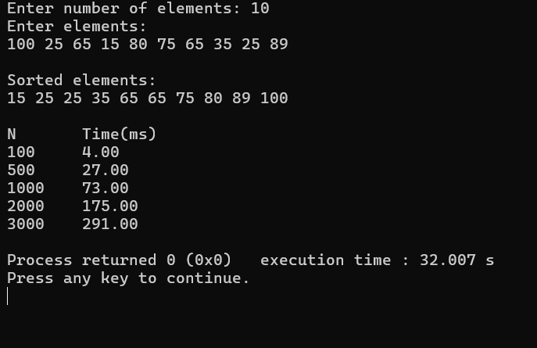

GRAPH:
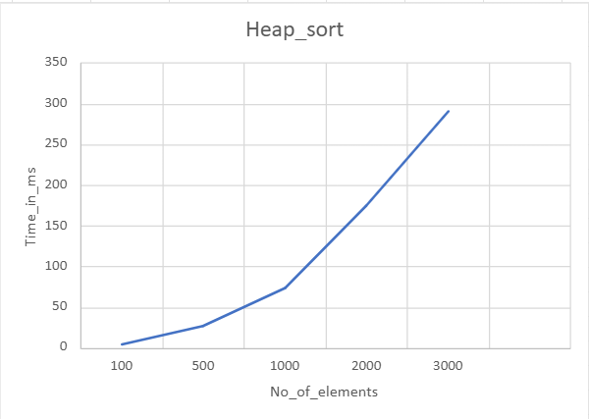

LAB PROGRAM 6:
#include <stdio.h> int max(int a, int b) {
return (a > b) ? a : b;
}

int knapsack(int W, int wt[], int val[], int n) { int i, w;
int K[n + 1][W + 1];

for(i = 0; i <= n; i++) {
for(w = 0; w <= W; w++) { if(i == 0 || w == 0)
K[i][w] = 0;
else if(wt[i-1] <= w)
K[i][w] = max(val[i-1] + K[i-1][w-wt[i-1]], K[i-1][w]); else
K[i][w] = K[i-1][w];
}
}
return K[n][W];
}

int main() { int n, W, i;
printf("Enter number of items: "); scanf("%d", &n);

int wt[n], val[n];

printf("Enter weights of items: "); for(i = 0; i < n; i++)
scanf("%d", &wt[i]);

printf("Enter values of items: "); for(i = 0; i < n; i++)
scanf("%d", &val[i]);

printf("Enter knapsack capacity: "); scanf("%d", &W);

printf("Maximum value = %d", knapsack(W, wt, val, n));
return 0;
}

OUTPUT :
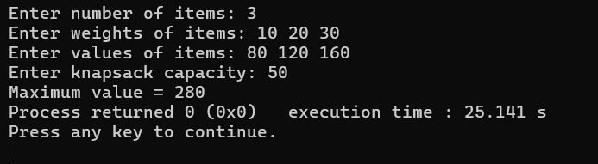

LAB PROGRAM 7:

#include <stdio.h> #define INF 999 int main() {
int n, i, j, k;

printf("Enter number of vertices: "); scanf("%d", &n);
int dist[n][n], graph[n][n];

printf("Enter adjacency matrix:\n"); for(i=0;i<n;i++) {
for(j=0;j<n;j++) { scanf("%d",&graph[i][j]);
dist[i][j]=graph[i][j];
}
}
printf("\nGraph with Weights:\n"); for(i=0;i<n;i++) {
for(j=0;j<n;j++) printf("%d\t",graph[i][j]);
printf("\n");
}

for(k=0;k<n;k++) for(i=0;i<n;i++)
for(j=0;j<n;j++) if(dist[i][k]+dist[k][j] < dist[i][j])
dist[i][j]=dist[i][k]+dist[k][j];

printf("\nAll Pair Shortest Path Matrix:\n"); for(i=0;i<n;i++) {
for(j=0;j<n;j++) printf("%d\t",dist[i][j]);
printf("\n");
}

return 0;
}

OUTPUT :
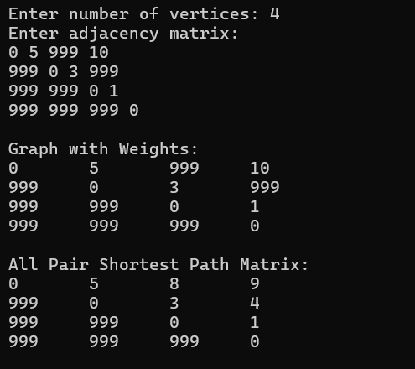

LAB PROGRAM 8(a) :
#include <stdio.h> #define INF 999 int main() {
int n, i, j, min, u = 0, v = 0, total = 0, edges = 0;

printf("Enter number of vertices: "); scanf("%d", &n);
int cost[n][n], visited[n];

printf("Enter cost adjacency matrix:\n"); for(i = 0; i < n; i++) {
for(j = 0; j < n; j++) scanf("%d", &cost[i][j]);
visited[i] = 0;
}

visited[0] = 1;
printf("\nEdges in Minimum Cost Spanning Tree:\n");

while(edges < n - 1) { min = INF;

for(i = 0; i < n; i++) { if(visited[i]) {
for(j = 0; j < n; j++) {
if(!visited[j] && cost[i][j] < min) { min = cost[i][j];
u = i; v = j;
}
}
}
}

printf("%d - %d : %d\n", u, v, min); total += min;
visited[v] = 1; edges++;
}
printf("\nMinimum Cost = %d\n", total); return 0;
}

OUTPUT :
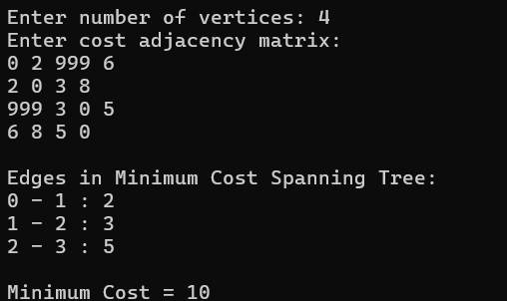

LAB PROGRAM 8(b) :
#include <stdio.h> #define INF 999 int parent[20];
int find(int i) { while(parent[i])
i = parent[i]; return i;
}

int uni(int i, int j) {

if(i != j) { parent[j] = i; return 1;
}
return 0;
}

int main() {
int n, i, j, min, a, b, u, v;
int cost[20][20], edges = 0, total = 0;
printf("Enter number of vertices: "); scanf("%d", &n);

printf("Enter cost adjacency matrix:\n"); for(i = 0; i < n; i++)
for(j = 0; j < n; j++) scanf("%d", &cost[i][j]);
printf("\nEdges in Minimum Cost Spanning Tree:\n"); while(edges < n - 1) {
min = INF;

for(i = 0; i < n; i++) { for(j = 0; j < n; j++) {
if(cost[i][j] < min) {
min = cost[i][j];
a = u = i;
b = v = j;
}
}
}

u = find(u); v = find(v);
if(uni(u, v)) {
printf("%d - %d : %d\n", a, b, min); total += min;
edges++;
}
cost[a][b] = cost[b][a] = INF;
}

printf("\nMinimum Cost = %d\n", total);
return 0;
}

OUTPUT :
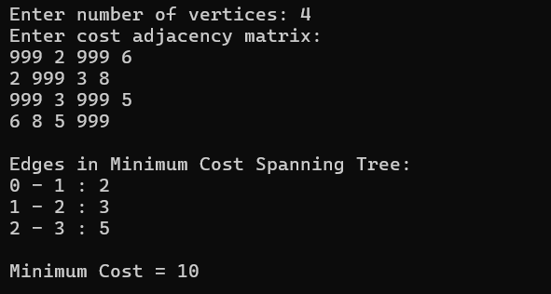
LAB PROGRAM 9:

#include <stdio.h> struct Item {
int weight, profit; float ratio;
};

int main() {
int n, i, j, capacity; float totalProfit = 0;
printf("Enter number of items: "); scanf("%d", &n);
struct Item item[n];
printf("Enter weight and profit of each item:\n"); for(i = 0; i < n; i++) {
scanf("%d %d", &item[i].weight, &item[i].profit); item[i].ratio = (float)item[i].profit / item[i].weight;
}

printf("Enter knapsack capacity: "); scanf("%d", &capacity);
for(i = 0; i < n-1; i++) { for(j = i+1; j < n; j++) {
if(item[i].ratio < item[j].ratio) { struct Item temp = item[i]; item[i] = item[j];
item[j] = temp;
}
}
}
printf("\nSelected Items:\n"); for(i = 0; i < n; i++) {
if(capacity >= item[i].weight) { capacity -= item[i].weight; totalProfit += item[i].profit;

printf("Item %d fully selected\n", i+1);
}
else {
totalProfit += item[i].ratio * capacity; printf("Item %d partially selected\n", i+1); break;
}
}

printf("\nMaximum Profit = %.2f\n", totalProfit);
return 0;
}

OUTPUT :
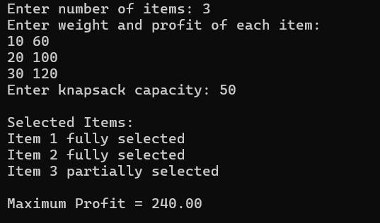

LAB PROGRAM 10:

#include <stdio.h> #define INF 999 int main() {
int n, i, j, source, count, min, next;

printf("Enter number of vertices: "); scanf("%d", &n);
int cost[n][n], dist[n], visited[n];

printf("Enter cost adjacency matrix:\n"); for(i = 0; i < n; i++)
for(j = 0; j < n; j++) scanf("%d", &cost[i][j]);
printf("Enter source vertex: "); scanf("%d", &source);
for(i = 0; i < n; i++) { dist[i] = cost[source][i]; visited[i] = 0;
}
dist[source] = 0;
visited[source] = 1;
count = 1;

while(count < n - 1) { min = INF;
for(i = 0; i < n; i++) {
if(dist[i] < min && !visited[i]) { min = dist[i];
next = i;
}
}
visited[next] = 1; for(i = 0; i < n; i++) {
if(!visited[i] && min + cost[next][i] < dist[i]) dist[i] = min + cost[next][i];
}

count++;
}
printf("\nShortest distances from vertex %d:\n", source); for(i = 0; i < n; i++)
printf("%d -> %d = %d\n", source, i, dist[i]);

return 0;
}

OUTPUT :
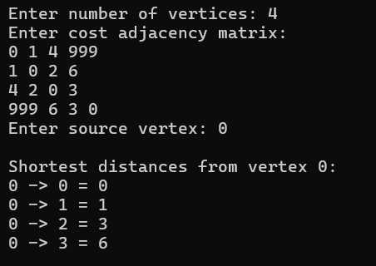

LAB PROGRAM 11:

#include <stdio.h> #include <stdlib.h>

int x[20], n;

int place(int k, int i) { int j;
for(j = 1; j < k; j++) {
if(x[j] == i || abs(x[j] - i) == abs(j - k)) return 0;
}
return 1;
}
void nQueens(int k) { int i, j;

for(i = 1; i <= n; i++) { if(place(k, i)) {
x[k] = i;

if(k == n) { printf("\nSolution:\n"); for(j = 1; j <= n; j++) {
for(i = 1; i <= n; i++) { if(x[j] == i)
printf("Q "); else
printf(". ");
}
printf("\n");
}
}
else
nQueens(k + 1);
}
}
}

int main() {
printf("Enter number of queens: "); scanf("%d", &n);
nQueens(1);

return 0;
}

OUTPUT :
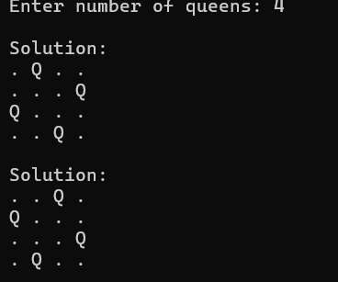

LEETCODE PROBLEMS :

1.Leetcode 704: Binary Search

Code:

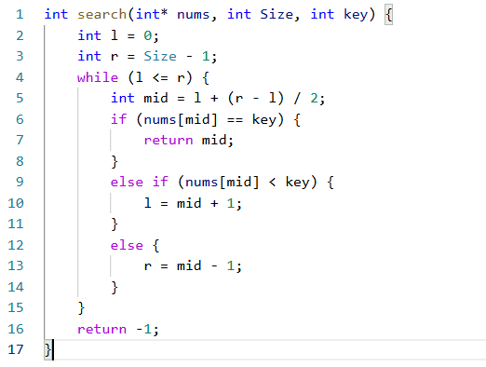

Output:

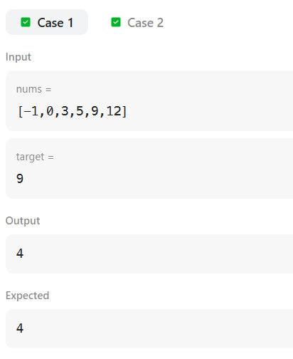

Leetcode 21: Merge two Sorted Arrays

Code:

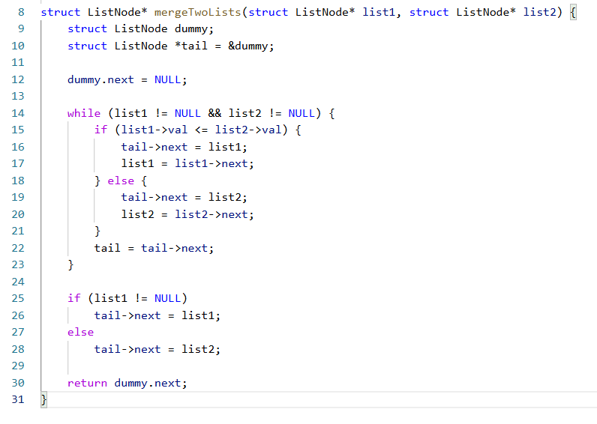
Output:

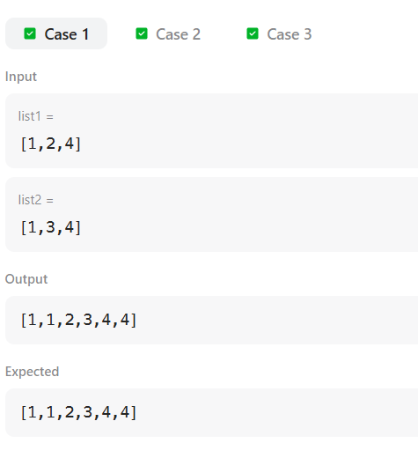

Leetcode 268 : Missing number in array

Code:

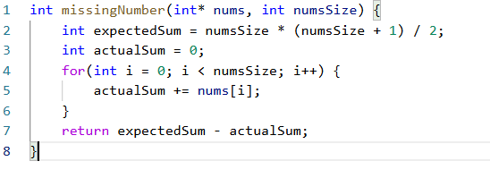

Output:

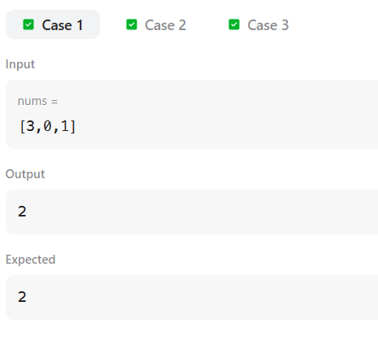

Leetcode 1636 : Sort array by increasing frequency

Code:

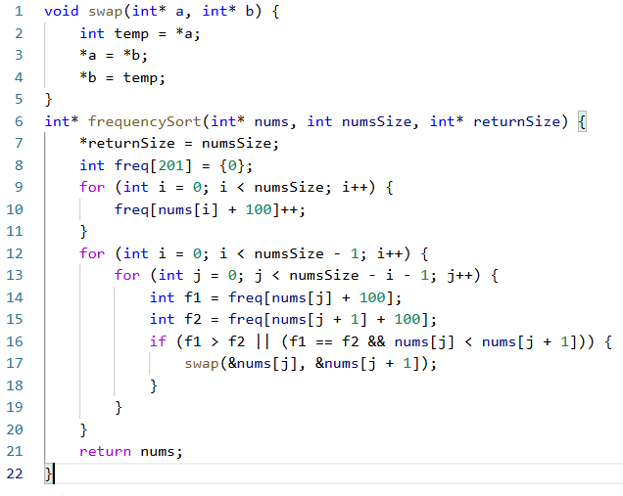

Output:

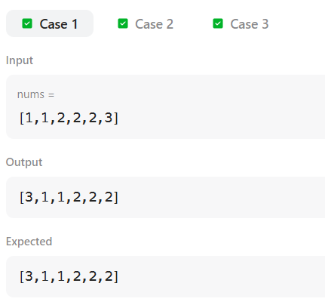

Leetcode 1005 : Maximum sum of Array after K negations

Code:

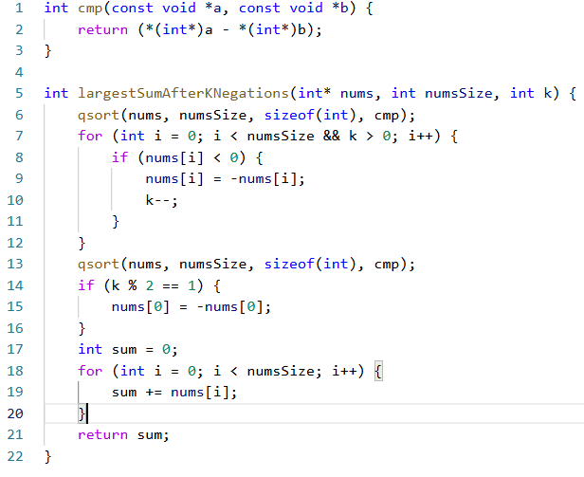
Output:

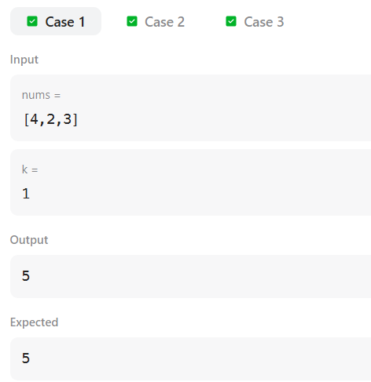

Leetcode 787 : Cheapest Flights within K stops

Code:

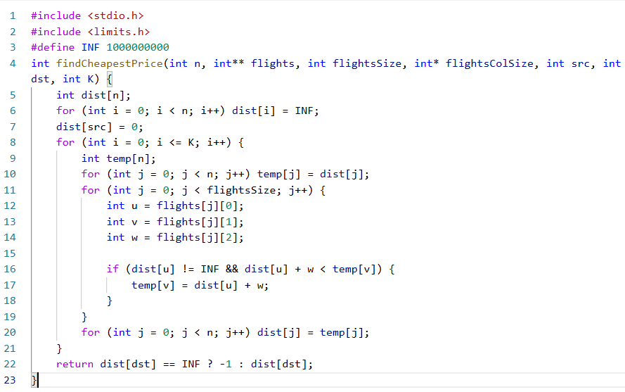
Output:

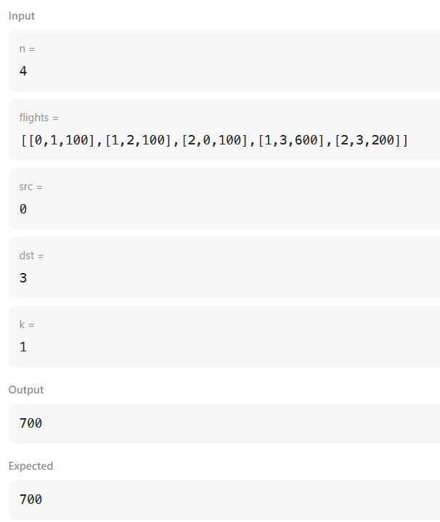

Leetcode 70 : Climbing Stairs

Code:

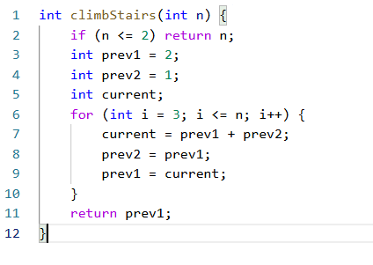
Output:

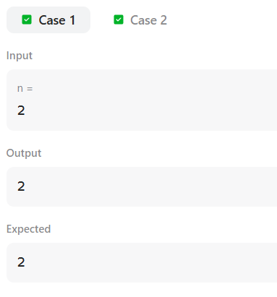

Leetcode 207: Course Schedule

Code:

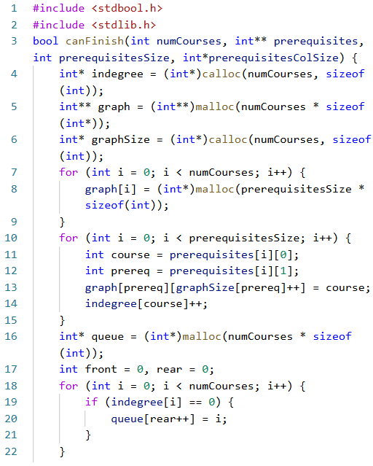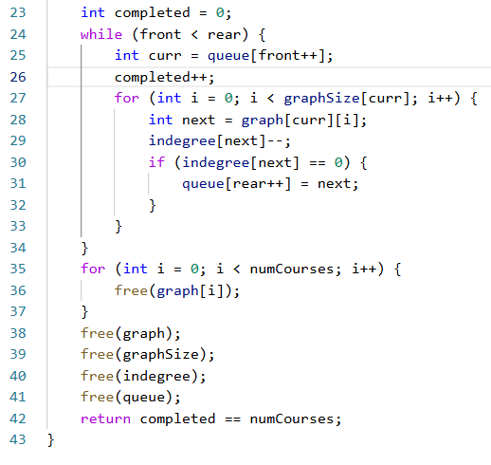

Output:

